ex1

//Alaa hawsawi, 27, Cents

#include <iostream>

using namespace std;

int main()

{

double quarters, dimes, nickels, sum;

cout<<"Enter how many quarters you have\n";

cin>>quarters;

quarters= 0.25 \* quarters;

cout<<"Enter how many dimes you have\n";

cin>>dimes;

dimes= 0.10 \* dimes;

cout<<"Enter how many nickels you have\n";

cin>>nickels;

nickels= 0.05 \* nickels;

sum= quarters + dimes +nickels;

cout<<"You have\t"<<sum<<"cents"<<endl;

return 0;

}

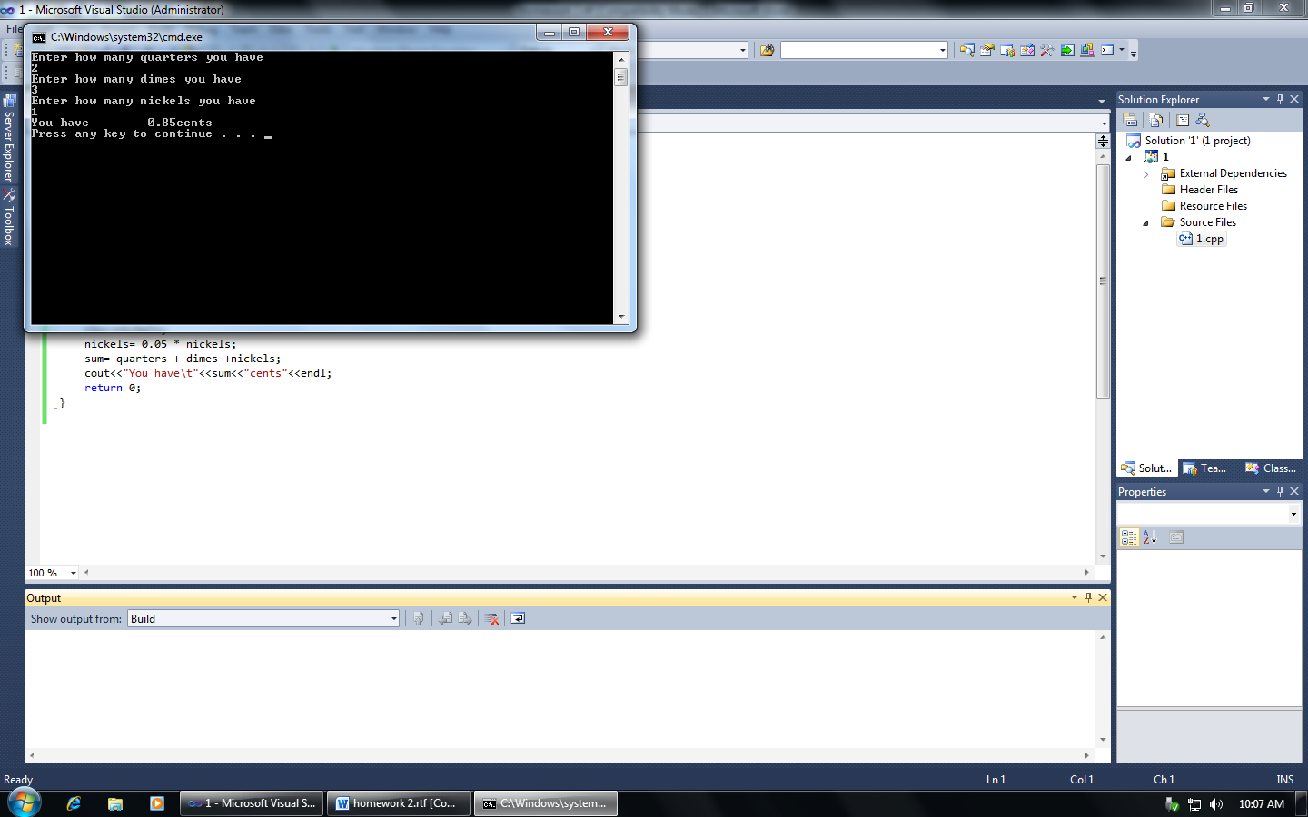

ex2

//Alaa Hawsawi, 27, Distance

#include <iostream>

using namespace std;

int main()

{

double distance, time, acceleration;

cout<<"Enter how many seconds\n";

cin>>time;

acceleration=32;

distance=(acceleration\*(time\*time))/2;

cout<<"the distance is\t"<<distance<<endl;

return 0;

}

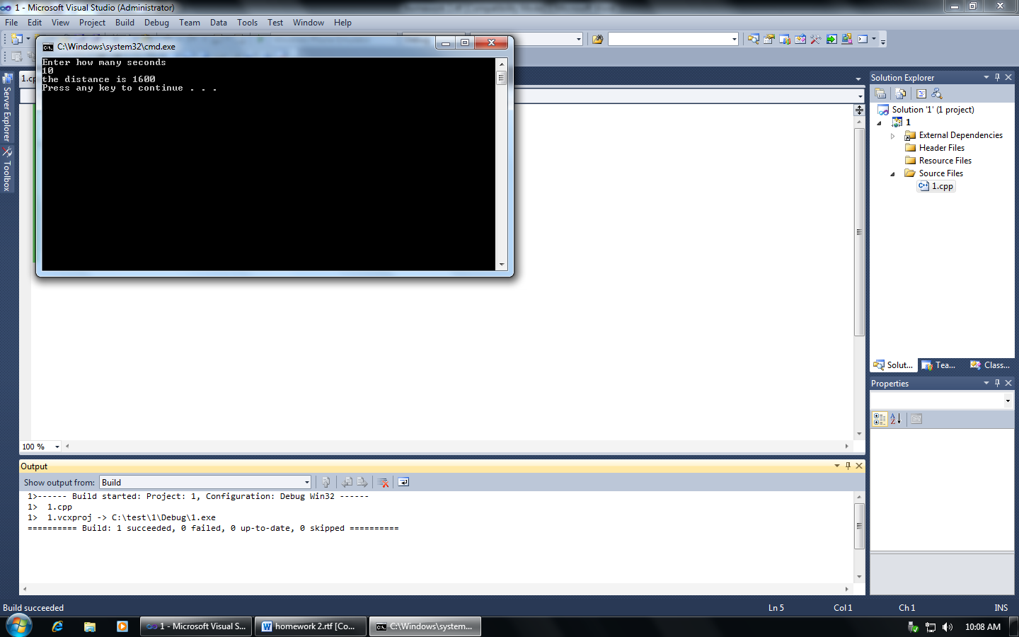

ex3

//Alaa Hawsawi, 27, surface and volume

#include <iostream>

using namespace std;

int main()

{

int num;

double area, volume, radius, radius2;

cout<<"Enter 1 to display a welcome message\n"<<"Enter 2 to calculate the surface area of a sphere\n"<<"Enter 3 to calculate the volume of a sphere\n";

cin>>num;

switch (num)

{

case 1:

cout<<"Welcome\n";

break;

case 2:

cout<<"Enter the radius for surface are of the a sphere\n";

cin>>radius;

area=(4\*3.14\*(radius\*radius));

cout<<"\t"<<area<<endl;

break;

case 3:

cout<<"Enter the radius for volume are of the a sphere\n";

cin>> radius2;

volume=(3\*3.14\*(radius2\*radius2\*radius2))/4;

cout<<"\t"<<volume<<endl;

break;

}

return 0;

}

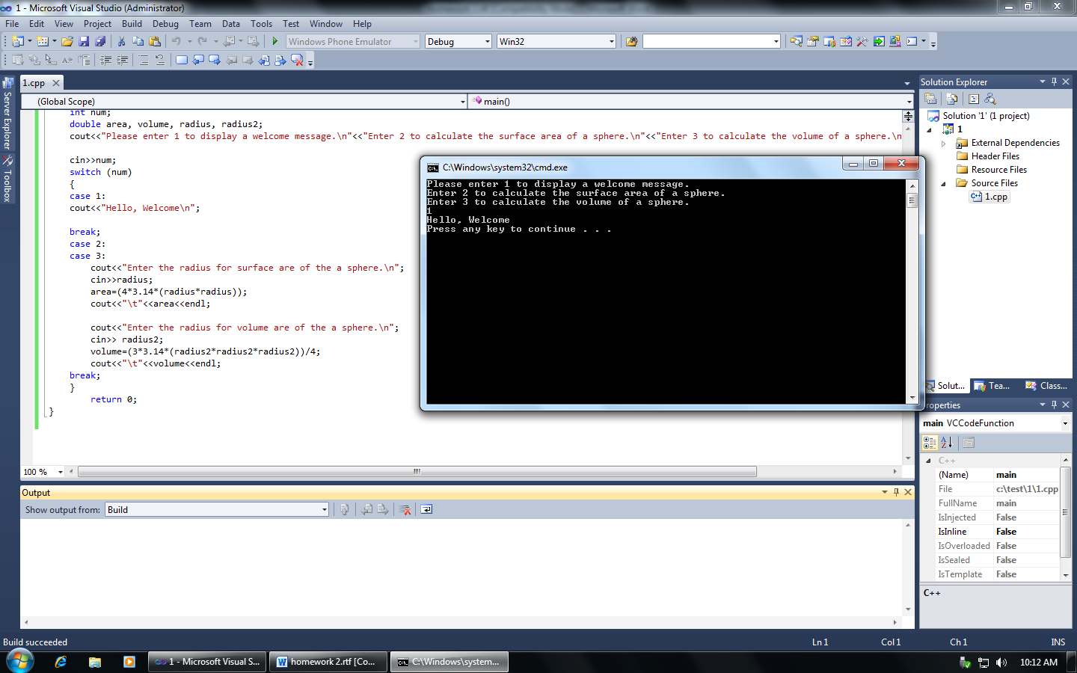

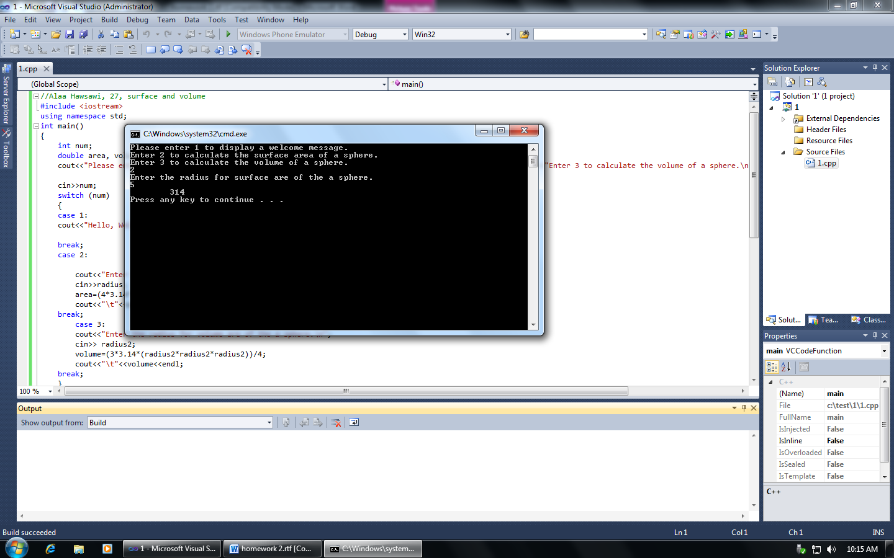

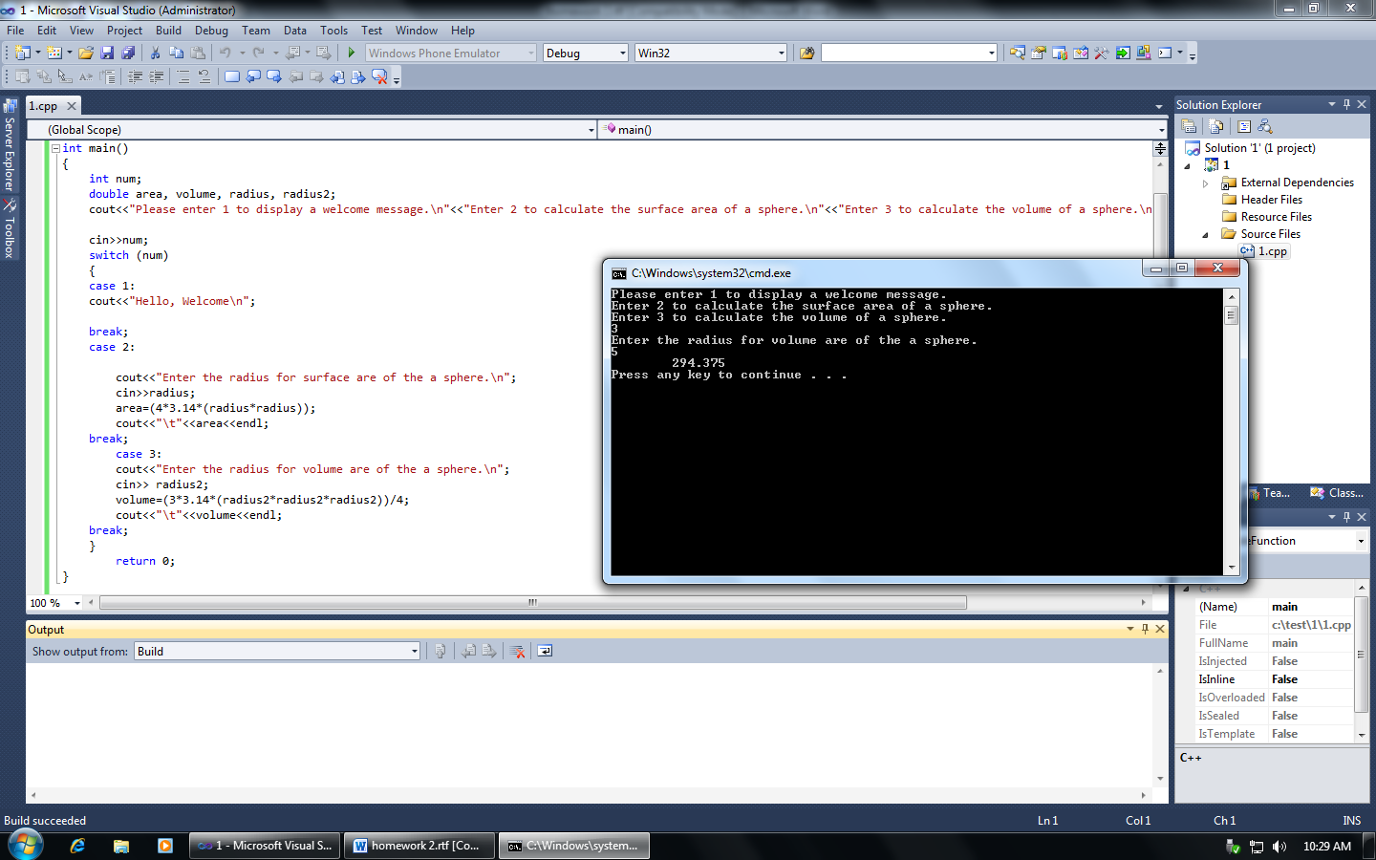

ex4

//Alaa Hawsawi, 27, Meeting

#include <iostream>

using namespace std;

int main()

{

double max, att;

cout<<"Meeting room\n";

cout<<"Please Enter Maximum Room Capacity\n";

cin>>max;

cout<<"Please Enter Attend people\n";

cin>>att;

cout<<"Maximum Room Capacity:\t"<<max<<endl;

cout<<"Attend people:\t"<<att<<endl;

if (att<= max)

cout<<"It is legal to hold the meeting\n"<<"It is legally to attend\t"<<max-att<<"\t persons"<<endl;

if(att>max)

cout<<"The meeting cannot be held as due to fire regulations\n"<<"They are\t"<<att-max<<"\t extra people"<<endl;

return 0;

}

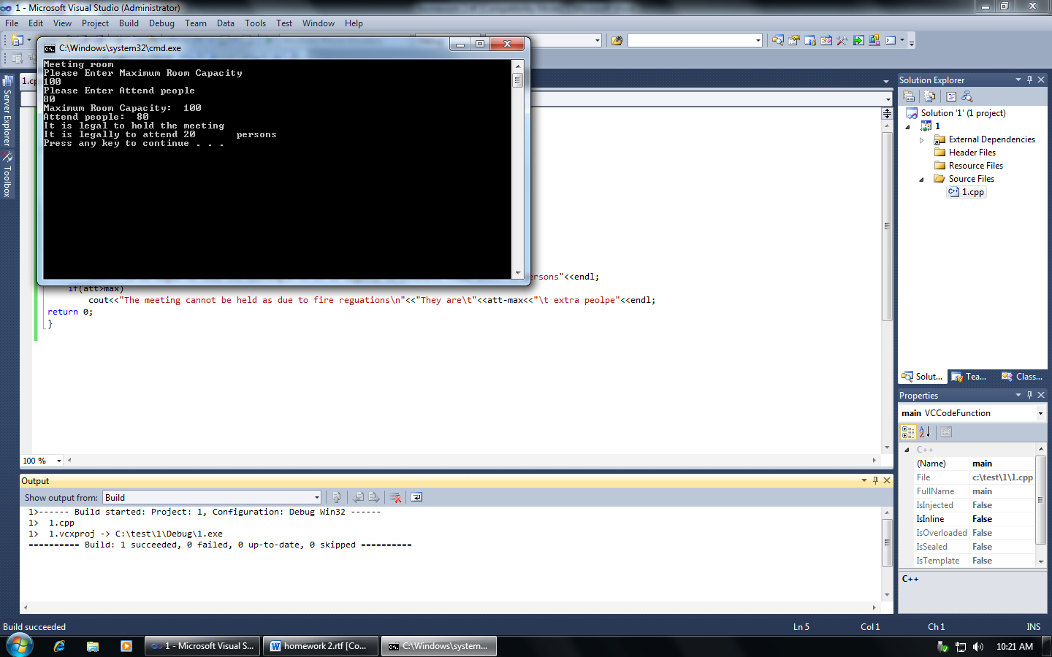

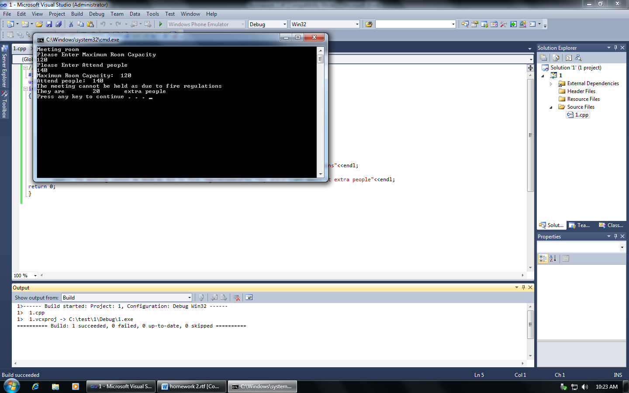

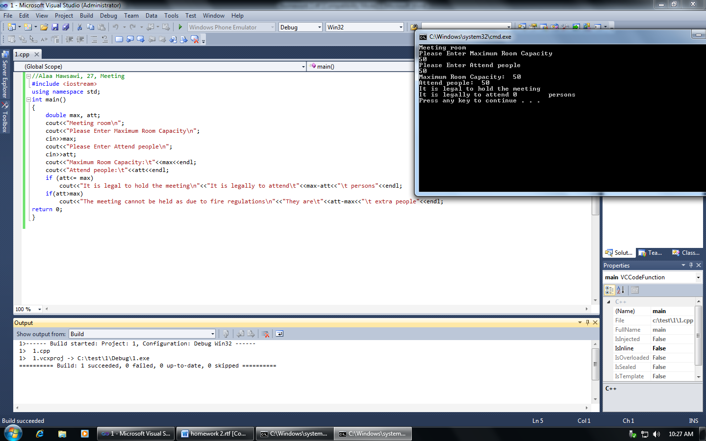

ex5

//Alaa hawsawi, 27, even and odd

#include <iostream>

using namespace std;

int main()

{

int num;

cout<<"please enter any number\n";

cin>>num;

if (num%2 == 0)

cout<<"even number\n";

else

cout<<"odd number\n";

return 0;

}

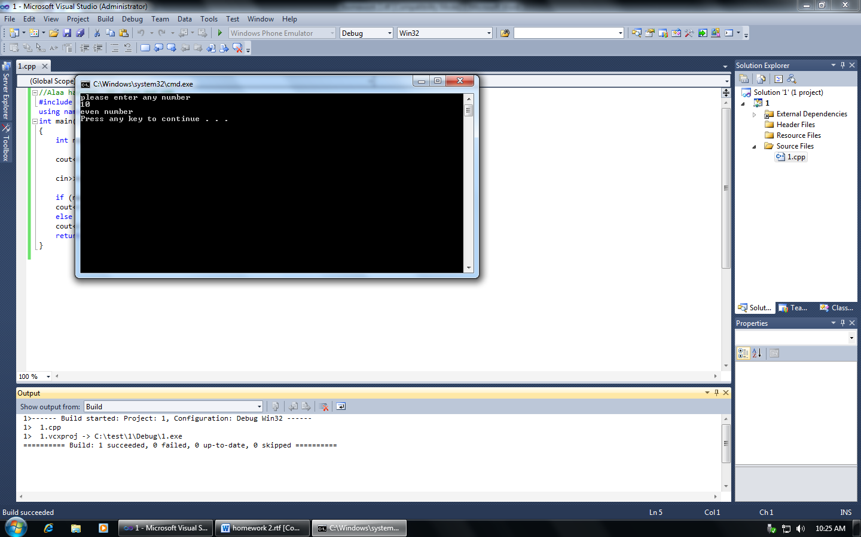

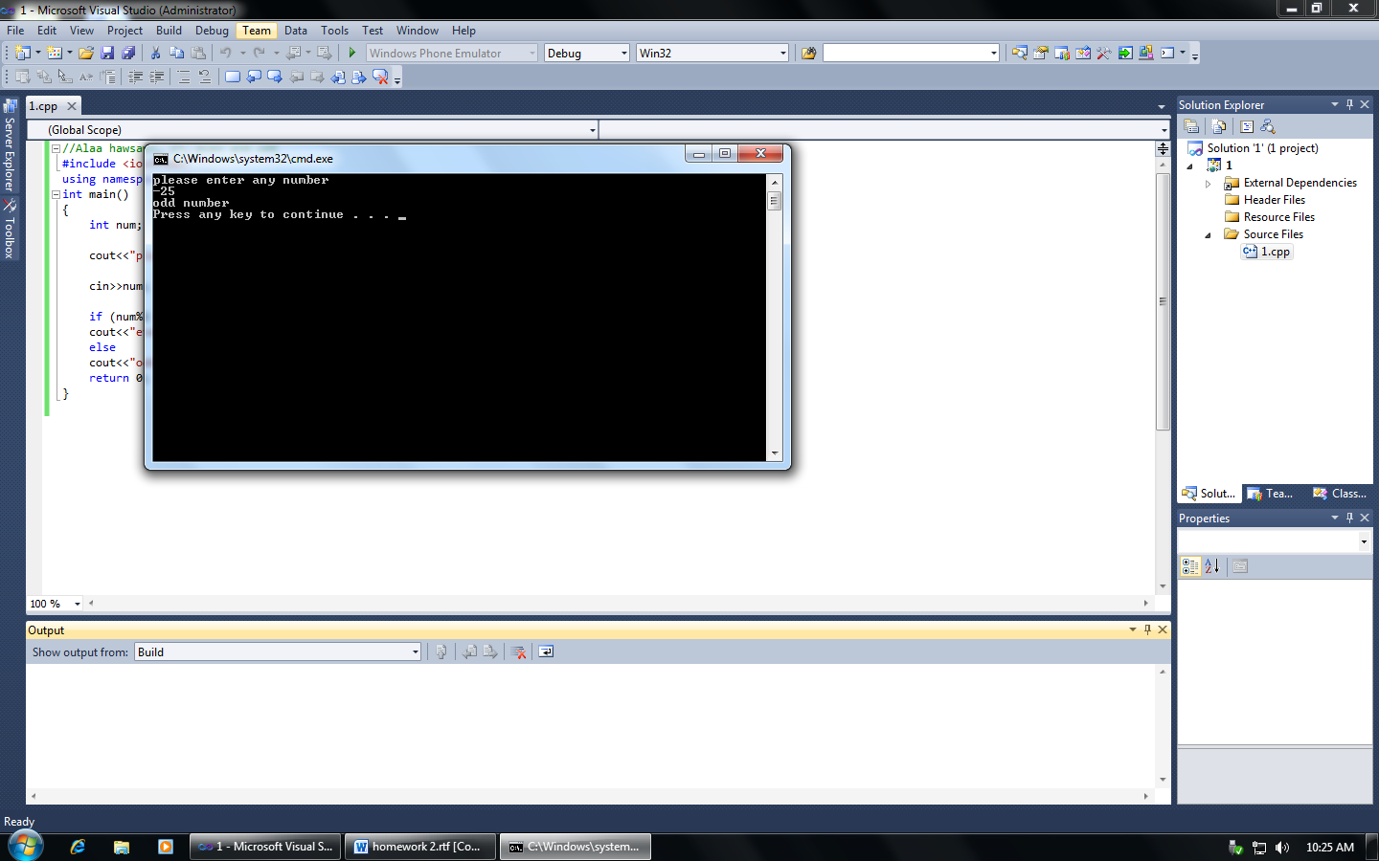

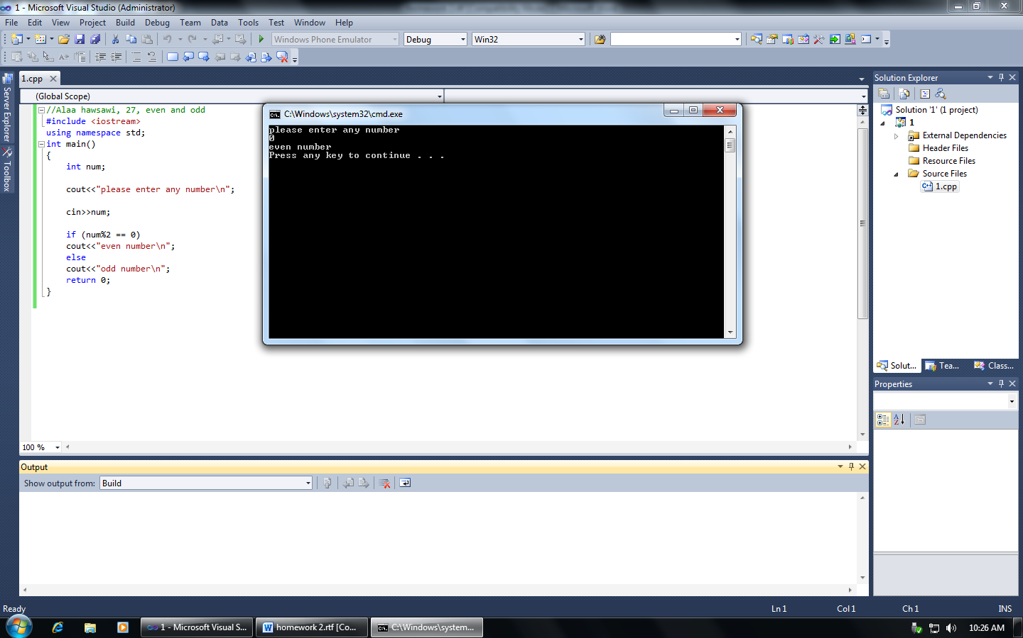

ex6

//Alaa Hawsawi, 27, year days

#include <iostream>

using namespace std;

int main()

{

int year, month;

cout<<"Please enter the month number 1-12.\n";

cin>>month;

cout<<"Month is\t"<<month<<endl;

if (month >=13)

{

cout<<"Sorry, it's\n";

exit (0);

}

cout<<"Please enter the year number .\n";

cin>> year;

if (year <1)

{

cout<<"Sorry, it's\n";

exit (0);

}

cout<<"The year\t"<<year<<((year%400 ==0) || (year%4 ==0) &&(year%100!=0)?"\t is a leap year\n":"\t is not a leap year\n");

switch (month)

{

case 1:

cout<<"there are 31 days in January"<<endl;

break;

case 3:

cout<<"there are 31 days in March"<<endl;

break;

case 4:

cout<<"there are 31 days in April"<<endl;

break;

case 5:

cout<<"there are 31 days in May"<<endl;

break;

case 6:

cout<<"there are 31 days in June"<<endl;

break;

case 7:

cout<<"there are 31 days in July"<<endl;

break;

case 8:

cout<<"there are 31 days in August"<<endl;

break;

case 9:

cout<<"there are 31 days in September"<<endl;

break;

case 10:

cout<<"there are 31 days in October"<<endl;

break;

case 11:

cout<<"there are 31 days in November"<<endl;

break;

case 12:

cout<<"there are 31 days in December"<<endl;

break;

cout<<"there are 31 days in \t"<<month<<endl;

break;

case 2:

cout<<((year%400 ==0)|| (year%4 ==0) &&(year%100!=0)?"there are 29 days in Frebruay \n":"there are 28 days in Frebruay\n");

break;

}

return 0;

}

